**A SEMINAR REPORT ON**

3D OPTICAL DATA STORAGE TECHNOLOGY

A SEMINAR REPORT SUBMITTED IN PARTIAL FULFILLMENT OF THE REQUIREMENT FOR THE AWARD OF THE DEGREE OF

MASTER OF TECHNOLOGY

IN

EMBEDDED SYSTEMS & VLSI DESIGN

SUBMITTED BY

K.KEERTHI

18S11D7006



#### DEPARTMENT OF ELECTRONICS AND COMMUNICATION ENGINEERING

#### MALLA REDDY INSTITUTE OF TECHNOLOGY AND SCIENCE

**MAISAMMAGUDA, DHULAPALLY, SECUNDERABAD-500014**

**(2018-2019)**

**Malla Reddy Institute of Technology and Science**

**Maisammaguda, RangaReddy .**



**BONAFIDE CERTIFICATE**

Certified that this technical seminar entitled “3D OPTICAL DATA STORAGE TECHNOLOGY **”,** being submitted by **K.KEERTHI** bearing roll no **18S11D7006** in partial fulfillment for the award of Degree of Master of Technology in **EMBEDDED SYSTEMS & VLSI DESIGN**, during the academic year **2018-19**.

Head of the Department, ECE

**ACKNOWLEDGEMENT**

It is great pleasure for me to express my grateful thanks to my honourable principal **Dr.K.Ravindra,** who had inspired a lot through his speeches. He is the only personality who had given the meaning to the technological studies and told me to survive in this competitive world.

I express my deep sense of gratitude and heart full thanks to **N.Neelima,** head of the department of Electronics and Communication Engineering for her cheerful motivation and encouragement at each stage of this endeavour.I was highly indebted to her.

I record with pleasure our deep sense of gratitude to all staff members for their stimulating guidance and profuse assistance. I have received from them throughout the course of the seminar. I shall always cherish my association with their encouragement, approachability and freedom of thought and action I have enjoyed during this work. I wish to thank all staff members and my friends who have helped in completion of seminar.

**K.KEERTHI**

**(18S11D7006)**

**ABSTRACT**

In this paper, Storing data is an important task in our regular life,this process is having a great history as magnetic tapes,gramophone records,floppy disks,optical storage disks,flash cards and so on.So the change is in the amount of size of data it can store and the space occupied of disk.For this 3D optical type is going to be a best alternative.

.

**CONTENTS PAGE NO**

1. INTRODUCTION 1
2. OPTICAL RECORDING TECHNOLOGY 2
3. HISTORY AND OVERVIEW 3

A. HISTORY

B. OVERVIEW 5

1. PROCEDURE FOR CREATING WRITTEN DATA 6

1. WRITTEN BY NONREONANT MULTIPHOTON ABSORPTION

B.WRITTEN BY SEQUENTIAL MULTIPHOTON ABSORPTION 9

1. CONCLUSION 10
2. REFERENCES 11
3. CONCLUSSION 12

**LIST OF FIGURES PAGE NO**

1.OPTICAL READING TECHNOLOGY

2. COMPACT DISC 3

3. SCEMATIC REPRESENTATION OF ACROSS SCTION THROUGH

A 3D OPTICAL STORAGE 5

4. A HOLOGRAPHIC VIDEO DISC AND A DVD13 7

5. A BLUE RAY DISK 8

**1. INTRODUCTION**

3D optical data storage is the term given to any form of [optical](http://en.wikipedia.org/wiki/Optical)[data storage](http://en.wikipedia.org/wiki/Data_storage_device) in which information can be recorded and/or read with [three dimensional](http://en.wikipedia.org/wiki/Three-dimensional_space)[resolution](http://en.wikipedia.org/wiki/Optical_resolution) (as opposed to the [two dimensional](http://en.wikipedia.org/wiki/Two_dimensional) resolution afforded, for example, by [CD](http://en.wikipedia.org/wiki/CD)).

This innovation has the potential to provide petabyte-level mass storage on DVD-sized disks. Data recording and readback are achieved by focusing lasers within the medium. However, because of the volumetric nature of the data structure, the laser light must travel through other data points before it reaches the point where reading or recording is desired. Therefore, some kind of nonlinearity is required to ensure that these other data points do not interfere with the addressing of the desired point.

No commercial product based on 3D optical data storage has yet arrived on the mass market, although several companies are actively developing the technology and claim that it may become available soon.

**1**

## 2 . OPTICAL RECORDING TECHNOLOGY

Optical storage systems consist of a drive unit and a storage medium in a rotating disk form. In general the disks are pre-formatted using grooves and lands (tracks) to enable the positioning of an optical pick-up and recording head to access the information on the disk. Under the influence of a focused laser beam emanating from the optical head, information is recorded on the media as a change in the material characteristics.

The disk media and the pick-up head are rotated and positioned through drive motors controlling the position of the head with respect to data tracks on the disk. Additional peripheral electronics are used for control and data acquisition and encoding/decoding.

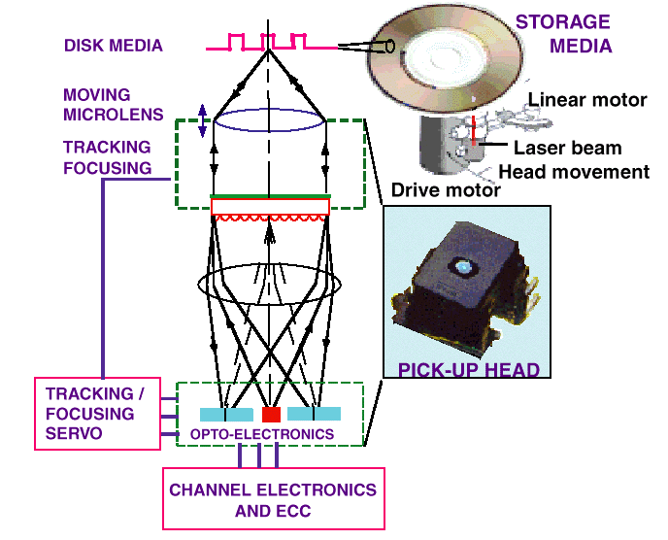

Fig 2.1: optical reading technology

**2**

STORAGE CAPACITY:

The storage capacity of an optical storage system is a direct function of spot size (minimum dimensions of a stored bit) and the geometrical dimensions of the media. A good metric to measure the efficiency in using the storage area is the areal density (MB/sq. in.). DATA TRANSFER RATE:

The data transfer rate of an optical storage system is a critical parameter in applications where long data streams must be stored or retrieved, such as for image storage or backup. Data transfer rate is a combination of the linear density and the rotational speed of the drive.

ACCESS TIME:

The access time of an optical storage system is a critical parameter in computing applications such as transaction processing; it represents how fast a data location can be accessed on the disk.

COST:

The cost of an optical storage system is a parameter that can be subdivided into the drive cost and the media cost. Cost strongly depends on the number of units produced, the automation techniques used during assembly, and component yields.

**3. HISTORY AND OVERVIEW**

1. **HISTORY**

The origins of the field date back to the 1950s, when Yehuda Hirshberg developed the [photochromic](http://en.wikipedia.org/wiki/Photochromic)spiropyrans and suggested their use in data storage. In the 1970s,ValeriBarachevskii demonstrated that this photochromism could be produced by two-photon excitation, and finally at the end of the 1980s Peter T. Rentzepis showed that this could lead to three-dimensional data storage. This proof-of-concept system stimulated a great deal of research and development, and in the following decades many academic and commercial groupshave worked on 3D optical data storage products and technologies. Most of the developed systems are based to some extent on the original ideas of Rentzepis. A wide range of physical phenomena for data reading and recording have been investigated, large numbers of [chemical](http://en.wikipedia.org/wiki/Chemical) systems for the medium have been developed and evaluated, and extensive work has been carried out in solving the problems associated with the optical systems required for the reading and recording of data. Currently, several groups remain working on solutions with various levels of development and interest in commercialization.

**B. OVERVIEW**

Current optical [data storage](http://en.wikipedia.org/wiki/Data_storage_device) media, such as the [CD](http://en.wikipedia.org/wiki/CD) and [DVD](http://en.wikipedia.org/wiki/DVD) store data as a series of reflective marks on an internal surface of a disc. In order to increase storage capacity, it is possible for discs to hold two or even more of these data layers, but their number is severely limited since the addressing laser interacts with every layer that it passes through on the way to and from the addressed layer. These interactions cause noise that limits the technology to approximately 10 layers. [3D](http://en.wikipedia.org/wiki/Three-dimensional_space) optical data storage methods circumvent this issue by using addressing methods where only the specifically addressed [voxel](http://en.wikipedia.org/wiki/Voxel) (volumetric pixel) interacts substantially with the addressing light. This necessarily involves nonlinear data reading and writing methods, in particular [nonlinear optics](http://en.wikipedia.org/wiki/Nonlinear_optics).

As an example, a prototypical 3D optical data storage system may use a disk that looks much like a transparent DVD. The disc contains many layers of information, each at a different depth in the media and each consisting of a DVD-like spiral track. In order to record information on the disc a [laser](http://en.wikipedia.org/wiki/Laser) is brought to a [focus](http://en.wikipedia.org/wiki/Focus_(optics)) at a particular depth in the media that corresponds to a particular information layer. When the laser is turned on it causes a [photochemical](http://en.wikipedia.org/wiki/Photochemical) change in the media. As the disc spins and the read/write head moves along a radius, the layer is written just as a DVD-R is written. The depth of the focus may then be changed and another entirely different layer of information written. The distance between layers may be 5 to 100 [micrometers](http://en.wikipedia.org/wiki/Micrometre), allowing >100 layers of information to be stored on a single disc.

**4**

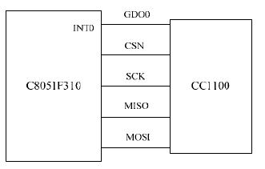

Fig 3: The Hardware Connection Between C8051F310 With CC1100

**B. CHOSEN OF GSM MODLUE**

As the third generation GSM dual frequency module, TC35 GSM module has the following features: compact and low power consumption; support dual frequency of GSM900 and GSM1800; provide standard AT command interface to users; provide fast, reliable and safe transmission of data, voice, short message and fax [4]. It is ideal for this system because of its high quality short message function.

**5**

**4. DESIGN OF SYSTEM SOFTWARE**

The system software, which is developed with C51 programming language, has two main modules, one for the WSN node communication, and one for the GSM communication.

**A. SOFTWARE MODULE FOR WSN NODE COMMUNICATIONS**

In the indoor wireless sensor network, the communication protocol is divided into three layers. The first layer is physical layer whose function has been implemented by CC1100 hardware itself. The second layer is network layer. The second layer is network layer which applies TEEN (threshold sensitive energy efficient sensor network) protocol. The data will be transmitted through the wireless sensor network only when the observed value changes suddenly.

The third layer is application layer. In this layer, the system’s application software is divided into two modules, WSN data collecting node software module and WSN center node software module. The latter, running on the master MCU of WSN center node, is responsible for wireless receiving data and judging whether it’s need to start the alarming process or not. If yes, it will drive TC35 GSM module to send alarm short message to user’s mobile phone. The software flow of center node module is illustrated in Fig. 4. And the software flow of data collecting node module is illustrated in Fig. 5.

**6**

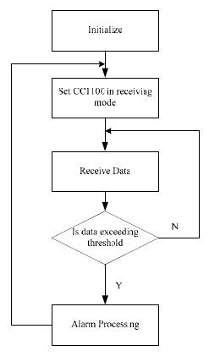

Fig 4: Software Flow Of Center Node Module

**7**

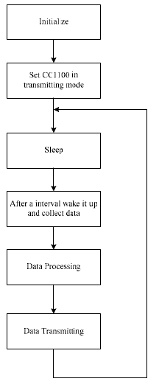

Fig 5: Software Flow Of Data Collecting Node Module

**8**

**B. SOFTWARE MODULE FOR GSM COMMUNICATION**

When the WSN center node module receives abnormal data, it will drive TC35 GSM module to send alarm short message through GSM network. TC35 GSM module supports standard AT command set. MCU control the operation of TC35 module by inputting different AT function commands through the serial port [5]. Some GSM AT commands relevant to short message are listed in table 1 [6].

The sending mode of short message depends on the interface supported by the short message service center in the GSM network. European Telecommunications Standards Institute (ETSI) has defined three kinds of interface protocol for sending short message: Block mode, Text mode and PDU mode. Block mode requires the mobile phone manufacture to provide driving support. Text mode doesn’t support Chinese text [7]. So at present, PDU mode has become the core of most mobile phone for their short message communication. It can provide more powerful functions than the other modes. So, this system applies PDU mode to send alarming short message.

**9**

**5. SET UP A PROTOTYPE SYSTEM AND TEST**

According to Fig.1, we set up a sample prototype system in our lab room. As mentioned above, choose C8051F310 MCU as the data processing unit of WSN center node module and data collecting node module. Here, C8051F310 has a temperature sensor imbedded that can detect the in-room temperature. After hardware connection, install the appropriate software developed with C51 on MCU-based indoor wireless control center. Then, we can start the test with this prototype system by changing the preset temperature threshold. When the actual in-room temperature exceeds this preset temperature threshold, the control center will immediately trigger TC35 GSM module to send an alarm short message to our mobile phone. Through the test process, this prototype system operated successfully and effectively with reliable and well communication.

**10**

**6. CONCLUSION**

This paper, presents one solution for establishing a low power consumption remote home security alarm system. The system, based on WSN and GSM technology, can detect the

theft,leaking of raw gas and fire, and send alarm message remotely. The hardware of this system includes the single chip C5081F310, wireless receiving and sending chip CC1100 as

well as the SIMENS TC35 GSM module. The system software developed in C51 language has the ability of collecting, wireless receiving and transmitting data, and can send a piece of alarm short message to the user’s mobile phone when some dangerous condition has been detected. With the advantages of reliability, easy usage, complement wireless, and low power

consumption, the system also has practical value in other fields.

TABLE I. SOME AT COMMANDS RELEVANT TO SHORT MESSAGE

|  |  |
| --- | --- |
| ***AT Command*** | ***Command Function*** |
| AT+CSMS | Select short message service |
| AT+CMGF | Set short message encoding mode (1 for text mode, 0 for PDU mode |
| AT+CMGS | Send short message |
| AT+ CSCA | Short message service center number |

**11**

**7. REFERENCES**

[1] Wu Chengdong, Zheng Jungang, Liu Daren, Xie Kun, “Study on Smart Home Network Technology Based on Wireless Sensor Network”, Academic Journal of Shenyang Jianzhu University, Vol. 21, No. 6, pp.753-756, Nov. 2005 (in Chinese)

[2] Ren Fengyuan, Huang Haining, Lin Chuang, “Wireless sensor network”, Journal of Software, Vol. 14, No. 7, pp.1282-1291, March, 2003 (in Chinese)

[3] Li Wenzhong, Duan Chaoyu, C8051F Series MCU and Short Distance Wireless Data Communication, Beijing, Beijing University of Aeronautics & Astronautics Press, 2007, pp.188-190 (in Chinese)

[4] Qiao Qu, Zhao Guohao, Wei Baohua, “Design of Home Safeguard System Based on GSM Technique”, Electronic Engineer, vol.32, No.11, pp.76-78, Nov.2006 (in Chinese)

[5] TC35 /TC37 Hardware Interface Description, Version 04. 00. 2002.

[6] AT Commands GSM Reference Guide,Revision A. 2003.

[7] Jin Rencheng, Zhangf Tianchao, “Design and Implementation of Security and Defense System based on GSM”, Computer Application, Vol.24 No.12, pp.75-77, Dec. 2004 (in Chinese)

**12**